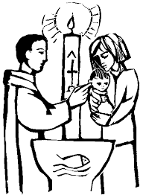
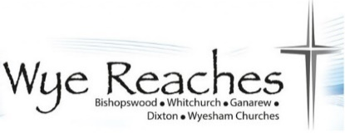

Wye Reaches Benefice

Child Baptism Request form

Please complete this form, sign it and then return it to revtimstarling@gmail.com
A member of clergy will then be in touch with you. Thank you.

Child/Children’s Details:
Child/Children’s Full Name:
Child/Children’s Date of Birth:
Fathers full Name: |  | Mothers full Name:
Mobile No: |  | Mobile No:
Email: |  | Email:
Home Address:
Home Telephone:
Father’s Occupation: |  | Mother’s  Occupation:
Has the father been baptised: |  | Has the Mother been baptised:
Has the Father been confirmed: |  | Has the Mother been confirmed:

Godparents details:
Full Name (1):
Address:
Email:
Are they baptised: |  | Are they confirmed:

Full Name (2):
Address:
Email:
Are they baptised: |  | Are they confirmed:

Full Name (3):
Address:
Email:
Are they baptised: |  | Are they confirmed:

Because of the very special role godparents have in supporting your child’s faith journey, they must be baptized themselves. Ideally, they should be confirmed too. Every child should have at least three godparents. Although there is no official maximum number of godparents, three or four is usual

Additional Information:
Which church are you looking for the baptism to take place in:

Do you have some dates in mind for the service:

Is there any additional information that you think it might be helpful for us to know:

By signing this form, I/we am/are giving permission for the clergy to use your data in accordance with the Church of England’s General Data Protection Policy. Further information can be found on the Church of England website.

I/we am/are giving consent for my child to be baptised/christened by a Church of England member of clergy within the Wye Reaches group of churches.

We would love to stay in touch with you after the Christening. If you would rather not be informed of church news or future events, please tick this box

Signed(*) by both parents: | Parent 1 | Parent 2
Dated:

If you have further questions, please do let us know. Thank you.

